Hillingdon Carers

We work closely with Hillingdon Carers who offer the following and more:

Information and Advice
- Expert Welfare Benefit advice
- Help with form filling
- Assistance in accessing Social Services support

Health and Wellbeing
- Relaxation sessions and weekly exercise or yoga
- Counselling and emotional support
- Training for carers
- Arts for carers course

Young Carers Services (5-17 years)
- 1-1 emotional support
- Young Carer Clubs across the borough

For more information:

Telephone: 01895 811206
Email: office@hillingdoncarers.org.uk
Website: www.hillingdoncarers.org.uk
Facebook: Hillingdon Carers
Twitter: @hillingdoncarers

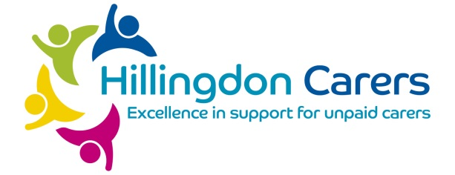
Are you a carer?

If you provide unpaid help or support to a relative, partner, friend or neighbour who could not manage without you, then you are a carer.

Recognising yourself as a carer can be the gateway to getting a range of help and support to allow you to continue your caring role.

Telling your GP

Please let us know that you are a carer.

You can tell any member of our team that you are a carer, whether it be a GP, Nurse, or a member of the reception team.

Caring impacts on your health

Carers are at a much higher risk of becoming ill themselves and your GP can help keep you fit and well by recognising the effects caring can have on your health, such as depression, stress, high blood pressure or back pain.

As a carer you are entitled to a free flu vaccination.

We will do our best to be flexible with appointment times to accommodate your caring situation.
Glendale Medical Centre
155 High Street, Harlington, Hayes
UB3 5DA
02088978288
www.glendalemedicalcentre.nhs.uk

Information for Carers

It is estimated that each year around 2 million carers begin caring and 2 million cease to be carers, so there is by no means a ‘static’ population of carers.

There are around 7 million carers in the UK.

There are 26,000 carers in Hillingdon.

YOU ARE NOT ALONE!

